Matthew Tran - Advanced Port Scanning

In this lab, I will learn how to combine Metasploit and Nmap to streamline the port scanning process. The goals are to:

- Find open ports on a target system.

- Identify services running on those ports.

- Enumerate services for additional information.

- Save and organize scan results for reporting.

Tools Used

- Kali Linux
- Metasploit Framework (msfconsole)
- Nmap
- PostgreSQL
- Terminal

Skills Learned

- Setting up and using Metasploit’s PostgreSQL database for storing scan results
- Creating and managing workspaces in Metasploit to organize penetration testing data
- Using Nmap within Metasploit with db_nmap to save scans directly to the database
- Performing targeted TCP and UDP scans to discover open ports and services
- Conducting service version detection and script scanning to gather detailed service information
- Identifying and enumerating remote access services like SSH and RDP
- Cleaning and managing host lists in Metasploit to maintain a focused target scope

- Advanced command line scanning with Nmap and Metasploit
1: Database Setup
I start by opening a terminal and preparing the Metasploit environment:

Steps I took:

- Opened a terminal window.

- Type sudo su to switch to root.

- Start PostgreSQL with service postgresql start (Metasploit requires this database).

- Initialize the Metasploit database with msfdb init.

- Launch Metasploit with msfconsole.

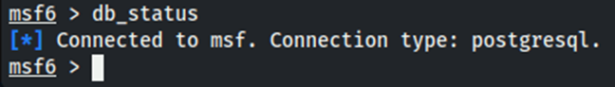
- Verify database connectivity with db_status. Which shows me: [*] connected to msf.

Metasploit uses PostgreSQL to store scan results, host information, services, and vulnerability data. This setup will create a structured environment where all findings are automatically cataloged for later analysis.
2: Set up workspace
Steps taken:

- In the msfconsole, type: workspace --add metasploitable

- Verify the workspace with workspace. The active workspace is marked with a red asterisk: * metasploitable.

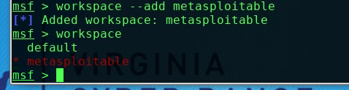
I created a dedicated workspace to keep my scans separate and organized, just like a professional penetration tester would for different clients or projects.

3: Check my Ip

I run ip addr show to identify my machine’s IP and subnet.
10.1.173.156/20

This allows me to exclude my own machine from scans.

4: find the target Metasploitable machine

Steps taken:

- Opened a new terminal window
- Became root
- Typed nmap -sS -Pn -v -p 22 10.1.173.156/20 | grep 'open' and nmap -sS -Pn -p 22 10.1.173.156/20 | grep -B4 'open'
I then scanned only port 22 across the subnet since it’s a known open port on Metasploitable, making it a fast way to locate the target.

The host IP on the Metasploitable machine is 10.1.173.156.

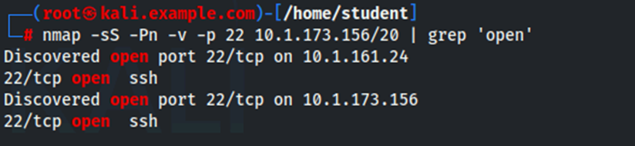
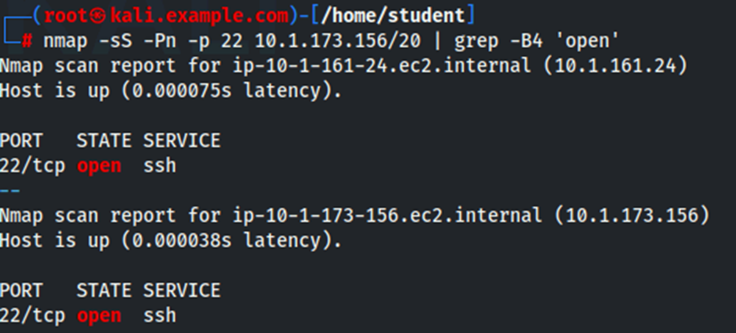

- Discovering open ports and services with Metasploit and Nmap

I returned to the terminal window with the Metasploit Framework running at the msf6> prompt.
Steps taken:
- I typed db_nmap 10.1.173.156. I used db_nmap so results would be saved directly into the Metasploit database for easy querying later.

- Type db_nmap -F -sS -n -v --open --reason 10.1.173.156 and pressed enter.

To view current host results stored in my workspace I typed hosts.
To view the current services stored in my workspace I typed services.

I then opened and completed a comprehensive background scan:

- Typed sudo su and pressed enter.
- Typed msfconsole and pressed enter.
- Typed workspace metasploitable and pressed enter.
- Typed db_nmap -T4 -p- -sS -n -v --open --reason 10.1.173.156 and pressed enter.

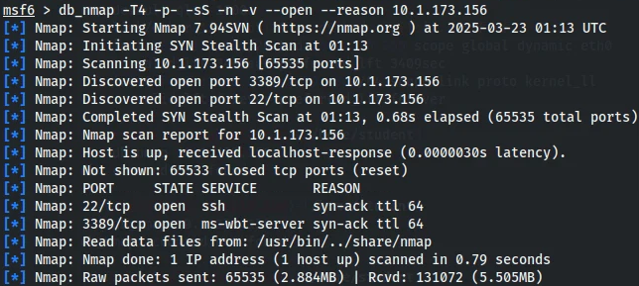
Services found and what ports and protocols were running
Services and Ports:

SSH on port 22/tcp

Microsoft Remote Desktop on port 3389/tcp

The scan revealed that the host 10.1.173.156 has two open ports. SSH (port 22) and Microsoft Remote Desktop (port 3389). Both services are used for remote access and are potential targets for exploitation if not properly checked and secured.

- Run a UDP scan using Metasploit and Nmap

I performed a UDP scan to uncover services like DHCP or SNMP that only listen on UDP ports and might be missed by TCP scans.
I typed db_nmap -sU -n -v --open --reason 10.1.173.156 and found DHCP Client on port 68/udp in an open|filtered state.

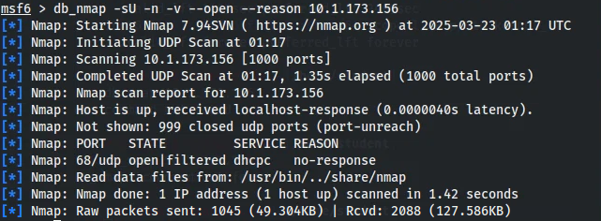
Port 68/udp is potentially open or filtered. This port is associated with the DHCP client, which is used for obtaining network configuration parameters. The open|filtered state tells us that Nmap could not determine if the port is open because of the lack of response from the host.

Task 4: Service Version Scanning
I used version detection and default scripts to gather detailed information about the discovered services, which is very important for vulnerability assessment.
I typed db_nmap -sS -sV -sC -v -n -p 22,3389 10.1.173.156.
new information was discovered:

Port 22/tcp (SSH):

Service Version: OpenSSH 9.7p1 Debian 5 (protocol 2.0)

RSA key: 81:30:15:af:68:43:a0:7d:42:4d:80:74:b4:96:7f:62

ECDSA key: 8f:05:fb:57:87:35:77:76:bb:e9:12:47:08:c4:07:82

ED25519 key: db:0a:30:9d:ai:6f:29:4a:af:81:d4:67:67:db:3b:04

Port 3389/tcp (Microsoft Remote Desktop):

Service Version: xrdp

Service Info: OS: Linux; CPE: cpe:/o:linux:linux_kernel
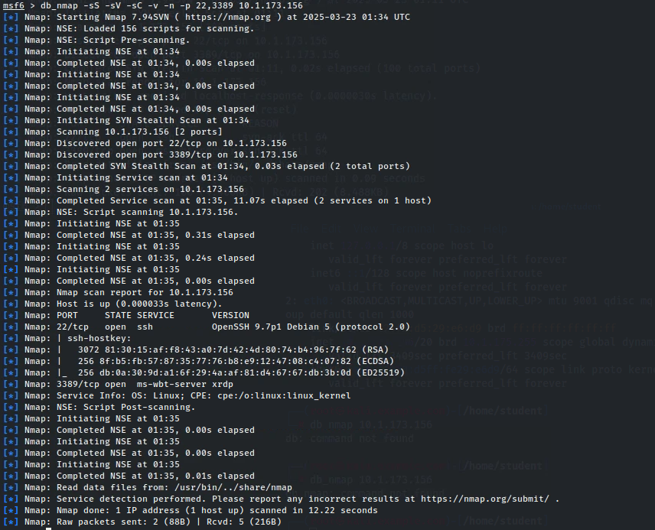
SSH: The target is running OpenSSH 9.7p1 on a Debian-based Linux system. The SSH host keys indicate strong cryptographic support.

RDP: The target is running xrdp, an open-source RDP implementation, on a Linux system. Xrdp is usually associated with Windows, making it a potential attack vector if misconfigured.
This information helps in identifying potential exploits.

Task 5: Cleaning up host list

I would clean the hosts list to remove non-target entries, keeping my results focused and within the authorized scope for professional reporting. That is if I had any extra hosts I did not want on the list.
Steps I would’ve taken:
1. I type hosts in the msfconsole to view my hosts.
2. I type hosts --d <host IP to delete> to delete any non-target hosts.

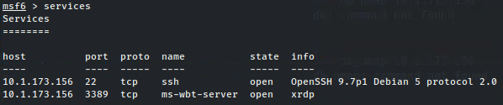
This final screenshot shows the results:
Displays the services running on the Metasploitable machine (10.1.173.156).
Open ports (22/tcp, 3389/tcp).
Service names (SSH, ms-wbt-server).
Protocols (TCP).
Port 22/tcp: Running OpenSSH 9.7p1 for secure remote access on a Debian system.
Port 3389/tcp: Running xrdp, an open-source RDP service on Linux, allowing remote desktop access.

